The Right Brain Initiative

Teaching Artist Manual

  - 2015-16 School Year

Table of Contents
INTRODUCTION 3
PROGRAM PHASES 3
WHO TO CONTACT WITH QUESTIONS 3
RESIDENCY ROLES AND RESPONSIBILITIES 4
Arts Integration Coach 4
Right Brain Teaching Artists 4
SCHEDULING PROCESS 5
Overview 5
Co-Planning Meeting 5
PAYMENT PROCESS 6
Role of Young Audiences Staff 6
Step by Step 6
Pay Dates 6
Invoicing Reminder 7
PAYMENT FAQ 7
How do I know when and how much I’ll be paid? 7
Can I pick up my check at the Young Audiences office? 7
How do I know Young Audiences received paperwork I sent in? 7
All About Supplies 7
Reflection Meeting 8
FINGERPRINTING & BACKGROUND CHECK 8
CANCELLATION/INCLEMENT WEATHER 8
PHOTO RELEASES 8
ADDRESS CHANGES 9
ONLINE PROFILE UPDATES 9
WITHDRAWAL 9
PROFESSIONAL DEVELOPMENT REQUIREMENTS 9
REFLECTION AND EVALUATION 10
THE RIGHT BRAIN INITIATIVE STAFF 10
Regional Arts & Culture Council 10
Young Audiences of Oregon & SW Washington 10
Arts Integration Coaches 11
APPENDIX A: Payment Schedule/Procedures 12
APPENDIX B: Arts Services and Fees Form 13
APPENDIX C: Supply/Reflection Meeting Invoice 15
APPENDIX D: Field Trip Form 16
APPENDIX E: Professional Development Calendar 17
APPENDIX F: Right Brain Residency Plan 18
APPENDIX G: Teacher Feedback Form 20
APPENDIX H: Program Model Phases 21
APPENDIX I: Residency Pathway 22

INTRODUCTION
This guide will answer questions about processes and procedures regarding scheduling, payments and budgets for schools in The Right Brain Initiative.

The Right Brain Initiative is a program of the Regional Arts & Culture Council (RACC), a nonprofit arts services organization serving the Portland metropolitan area, including Clackamas, Multnomah and Washington counties. RACC serves as the Managing Partner and Young Audiences of Oregon & SW Washington serves as the Implementation Partner for the Initiative, coordinating the delivery of services including oversight of and support for teaching artists.

PROGRAM PHASES
Schools join The Right Brain Initiative through a stepped-in model, allowing schools to grow their involvement over time. Schools begin their work with Right Brain in Entry: year 1, in which they work with an Arts Integration Coach to focus on faculty engagement, develop their internal Right Brain structure and engage in an example residency (serving 2 classrooms). Full implementation of the program begins in the following year, Entry: year 2. In this year, our value for equity is met as all students within the school receive Right Brain arts integrated programming. Over time, all schools advance to the Sustaining phase, where schools take on ownership and internal leadership. (see APPENDIX H: for more information).

WHO TO CONTACT WITH QUESTIONS
For questions about your in-school programming contact the Arts Integration Coach assigned to your school (see page 10: THE RIGHT BRAIN INITIATIVE STAFF for contact information).

For general questions, including those about PD calendar and online profiles, contact:
Emily Stone 503-225-5900 ext. 234 estone@therightbraininitiative.org

For programmatic questions such as those about the Program Model, schools, coaches and teaching practice, contact:
Amy Botula 503-225-5900 ext. 229 amy@ya-or.org

For invoice or payment questions, contact:
Josephine Kuever 503-225-5900 ext. 231 josephine@ya-or.org

For questions about checks and tax forms, contact:
Fidel Devera 503-225-5900 ext. 222 finance@ya-or.org
To access this manual, as well as all other required residency materials, please visit the Right Brain website. First, go to the Participating Educators section (password: rightbrain) and scroll down until you come to the section entitled: “For teaching artists/arts providers.”
Submit paperwork to:
The Right Brain Initiative
c/o Young Audiences of Oregon & SW Washington
fax: 503-225-0953 email: josephine@ya-or.org
mail: 1220 SW Morrison, Suite 1000, Portland, OR 97205

RESIDENCY ROLES AND RESPONSIBILITIES

Arts Integration Coach
Arts Integration Coaches are Right Brain staff members who are paired with participating schools in the Entry 1, 2, and 3 year phases to guide the Right Brain planning process, develop school leadership and ownership, and facilitate decisions about serving students in The Right Brain Initiative.

Role:
Coaches will guide schools through the design and implementation of Right Brain arts-integrated residencies including identifying goals, facilitating meetings, and supporting the incorporation of 21st Century Skills. The Coach will work closely with each School Arts Team to develop a planning process that will work best for their school community. Coaches will be there to answer questions, support strong communication and honor people’s time and voices throughout the process.

Responsibilities:
- Convene and facilitate the school’s Arts Team planning meeting
- Advise Arts Team and school through artist identification process
- Provide guidance and support to Arts Team while planning and implementing residencies
- Facilitate and support collaborative planning between teaching artist and classroom teachers (co-planning meeting)
- Contact identified teaching artist in advance of co-planning meeting
- Coach classroom teachers and teaching artists toward high-quality residency experiences
- Convene and facilitate the reflection meeting
- Take notes at meetings and disseminate to all attendees
- Conduct informal classroom observations, offering insights for the enhancement of teaching and learning
- Serve as problem-solving resource if questions or challenges arise
- Coach schools toward development of internal leadership and ownership of Right Brain practices
- Convene and facilitate end-of-year school Arts Team meeting

Right Brain Teaching Artists
Role:
A Right Brain teaching artist provides meaningful and creative arts integration experiences in line with Right Brain values for students in participating schools. Right Brain teaching artists collaborate with classroom teachers in order to deepen the impact of their teaching on the students and the school. In addition, artists look for opportunities to share strategies that can be left behind and impact a student’s arts education beyond the time the artist is in the classroom.

Responsibilities:
- Determine with the school’s contact if you are the right fit for their residency goals
- Work out budget details with school contact (preferably in advance of co-planning meeting)
- Work with school (and Coach if they are in the Entry phases) to schedule co-planning meeting
- Attend co-planning meeting, (in Entry schools this is facilitated by Coach using Right Brain protocol)
- Determine residency schedule with school contact
- Fill out and submit fees paperwork before the start of the residency
- Communicate throughout residency with classroom teachers and Coach (at Entry schools) and/or Amy (at Sustaining schools)
- Attend reflection meeting, facilitated by Coach (Entry) or school leadership staff (Sustaining)
- If working in a school’s selected classroom, collaborate with the classroom teacher in the planning for student work design and collection to present at Spring Colloquium in May

SCHEDULING PROCESS

Overview
After an initial pre-planning School Arts Team meeting with the Arts Integration Coach (Coach), a School Arts Team member will get in touch with possible artists to determine the best fit for their school’s plan. In most situations, this will be a principal or teacher from a participating school. At this point, the school’s team will have already met for the pre-planning meetings and will be calling to inquire about your offerings, with their own school and classroom goals in mind. This phone call will be to work out whether you are a good fit for their plan. They’ll want to discuss project goals, your fees and schedule. You may consider having a list of your own questions for the school contact.

Co-Planning Meeting
A co-planning meeting (at Entry schools this is facilitated by the Arts Integration Coach) will be scheduled if they decide to work with you (APPENDIX I: Residency Pathway).

Purpose: To co-design an arts integrated field trip, performance and/or residency experience through facilitated co-planning between the artist and school.

Process: Prior to the co-planning meeting, the Coach for the school (or in the case with Sustaining schools—a School Arts Team member) will contact you to discuss the thinking the school has done so far in the pre-planning meeting, and to discuss the co-planning meeting. If you are working with the entire school or a number of classrooms in the building, it may be that you meet with only a representative group of teachers from the school who will then communicate the information from the planning meeting back to the rest of the staff, or that you might meet with all involved staff. This will be determined by the school.

The co-planning meeting will use the Right Brain residency plan (see Appendix APPENDIX F: Right Brain Residency Plan) to facilitate the conversation, focusing on the needs of the students and the classroom culture; connections between the arts experience you will be providing and the school/classroom goals and curriculum; and how possible projects can connect with the 21st Century Skills, Common Core and higher order thinking. This session will be guided by the Coach and/or School Arts Team. Towards the end of the meeting, there is a window of time to go over the logistics; the majority of logistics (dates, fees and supply estimates finalized) may be determined following the session with the primary school contact(s).

All costs need to be calculated carefully because many schools are working with a finite budget. This is especially true for supply estimates because your actual costs cannot exceed the estimate. (See Page 7 for more details about Supplies.)

Paperwork:
ARTS SERVICES AND FEE FORM (see APPENDIX B: Arts Services and Fees Form for an example): This document will be used to create invoices and initiate the ultimate payment process for any services. This paperwork is your responsibility. It is in your best interest that it is filled out completely and accurately, signed by yourself and principal, and submitted before the start of the program. It is better to find out about any financial miscalculations before you start, rather than after the residency.

Be sure to bring this form with you to the co-planning meeting!

After the form is completed at the co-planning meeting, fax to 503-225-0953, email to josephine@ya-or.org or mail to 1220 SW Morrison, Ste. 1000, Portland, OR 97205. It is the teaching artist’s responsibility to make sure the form is completed and submitted.

PAYMENT PROCESS
As Implementation Partner for The Right Brain Initiative, Young Audiences is charged with coordination and execution of the payment procedures. Therefore, you will submit your paperwork, including requests for supply reimbursement, to Young Audiences, who will create and track invoices and then issue payment for all artist services for Right Brain.

Role of Young Audiences Staff
Josephine Kuever, School Liaison, creates and tracks the paperwork as detailed below. If you have questions about what form to use and how to use them, please contact her at 503-225-5900 ext. 231 or josephine@ya-or.org.
Fidel Devera, Controller, produces payments and generates your annual IRS Form 1099. If you have questions about checks/direct deposit or if your tax information changes during the year please contact him at 503-225-5900 ext. 222 or finance@ya-or.org.

Step by Step
- Submit your IN-SCHOOL ARTS SERVICES AND FEES FORM to Young Audiences
- They will process it and send you a confirmation invoice via email. At this time, please check to make sure all the details are correct (including your address)! Your pay date(s) and amounts will be listed. The amount shown on the invoice will be the estimated total cost minus any supply costs and the reflection meeting fee.
- Submit a SUPPLY/REFLECTION MEETING INVOICE to Young Audiences after purchasing supplies and/or after the reflection meeting.
- Young Audiences will process it and send you a confirmation invoice via email with your pay date listed.

Pay Dates
Artist payments will generally be made every other Monday. For a detailed schedule of pay dates, please see Appendix A. Invoices must be received by noon on Wednesday prior to the pay date to be included in that check run. When a pay date falls on a holiday, payments will be made on the Tuesday of that week.

In-School Services Policy:
- For services up to 15 days in length, payment will be made on the first pay date after the end of the work.
- For services 15-60 days in length, 50% of the total payment will be paid on the pay date at the mid-point of the work and the balance at the first pay date after the end of the work.
- For services over 60 days in length, four equal payments will be evenly spaced over four dates, the first payment occurring on the pay date one-quarter of the way through the work and the final payment occurring on the first pay date after the end of the work.
Field Trips Policy: Ticket and/or entrance fees will be paid based on the date(s) you provide on the invoice you submit. Submission of the signed Arts Services and Fee form at the end of the planning meeting is all that is needed to initiate payment of the planning meeting fee.

Invoicing Reminder
Supply costs and your reflection meeting fee must be invoiced separately using the SUPPLY/REFLECTION MEETING INVOICE (see APPENDIX C: Supply/Reflection Meeting Invoice for an example). Please review your invoice to make sure all information is correct and contact Young Audiences if any changes to the schedule or fees occur.

PAYMENT FAQ

How do I know when and how much I’ll be paid?
Artist pay dates are every two weeks and follow the schedule listed in Appendix A. If you are doing a residency over 15 days, there will be multiple pay dates. If the residency is under 15 days, you will be scheduled to be paid on the next artist pay date after the last date of the residency. These dates and the amounts will be detailed on the ARTIST SCHEDULE AND INVOICE you receive from Young Audiences.

Your payment(s) will equal the amount shown on the invoice, which will include the artist fee for planning meeting, fee for program, travel cost, and any additional prep time. The fee for reflection meeting and supplies must be invoiced separately by the artist and will be paid separately from the primary invoice.

Can I pick up my check at the Young Audiences office?
Certainly! Please send Fidel (finance@ya-or.org) an email letting him know to hold your check. They are usually ready by 3pm on the pay date but please call to make sure before you stop by the office. Checks that are over $2,500 need to also be signed by a board member so there may be a slight delay in those cases.

How do I know Young Audiences received paperwork I sent in?
You will know Josephine received your Arts Services and Fee form when you receive the ARTIST SCHEDULE AND INVOICE via email.

You will know she received your SUPPLY/REFLECTION MEETING INVOICE when you receive an ARTIST SUPPLY INVOICE via email.

In general, these confirmation invoices are emailed to the artist immediately after processing.

All About Supplies
The purchase of all supplies is the arts provider’s responsibility. Supply costs will then be reimbursed by The Right Brain Initiative. In order to be reimbursed for supplies, you must submit a SUPPLY/REFLECTION MEETING INVOICE form (see APPENDIX C: Supply/Reflection Meeting Invoice for an example) and receipt copies for all purchases.

If you bulk-purchase supplies or own equipment and use them for residencies or workshops for several contracts, please create an invoice detailing the specific costs of the materials used for each contract and submit that as your receipt with the SUPPLY/REFLECTION MEETING INVOICE form.

Please submit this form and copies of your receipts to Josephine at Young Audiences within one month of the date of completion of the residency. The Corresponding Contract number requested can be found on the top of your ARTIST SCHEDULE AND INVOICE form.

As the schools have a fixed Right Brain budget, actual supply costs cannot exceed your estimate. If you do exceed your estimate by any amount, there is no guarantee that the school will be able to cover the overage. Therefore it is recommended that you estimate carefully and accurately to avoid any issues and always check with the principal before spending more than was budgeted.

Reflection Meeting
After your reflection meeting, please submit the SUPPLY/REFLECTION MEETING INVOICE form with the date and cost of the meeting filled out. The form should be signed by the arts provider and the school’s Coach (if applicable). If you are submitting a supply reimbursement request for the same contract at the same time, please include that information and receipts on the same SUPPLY/REFLECTION MEETING INVOICE. You may invoice for supplies and your reflection meeting separately.

FINGERPRINTING & BACKGROUND CHECK
To offer residencies and workshops (except for one-time, pre- or post- performance workshops) through The Right Brain Initiative, you must have passed the Oregon state fingerprinting and background check approval process designed for public schools and conducted by Portland Public Schools (PPS), and received your badge before beginning work in the schools.
As of 2013-14, badges are valid for 3 years and fingerprinting is a one-time process.

Please note that this is a requirement for your volunteer helpers as well. If you have someone (other than a parent at that school) that you regularly bring in to assist you, they will need to have a badge prior to arrival. PPS is quite strict about this. If you have questions about this, or need paperwork for your volunteer helpers, please contact Amy.

CANCELLATION/INCLEMENT WEATHER
Prior to the service date, cancellation of a service for any reason must be approved by both the school and Right Brain.

In event of inclement weather that results in official closing of the school or an emergency on the day that a service is scheduled, please contact the school principal, or other designated person, as soon as possible to the scheduled service and also immediately notify Amy at 503-225-5900 ext. 229 (or amy@ya-or.org).

PHOTO RELEASES
If you would like to have any images of your work in a classroom (or student work) for your own use, please use our generic photo permission form (visit The Right Brain Initiative’s website to download a template) and work with individual classroom teachers to secure parent permissions (well in advance of your residency).

You will also note that Right Brain is working to document in select residencies, both students and their work. As each school will have one classroom that is being documented photographically (or with video); Right Brain works to collect parent permission forms for that classroom. If you would like to also have use of the photographs taken in that classroom, please coordinate with that teacher to have your own permission form distributed as well. Otherwise, you will have permission to use resulting Right Brain photos restricted to: images of yourself only for whatever purpose you’d like and images of you and students or students only for use only on your Right Brain profile page.

Note: Feel free to share the link to our Flickr page (http://www.flickr.com/photos/therightbraininitiative/sets/) with parents and other teachers as well. You can also do fun things like show a slideshow of your set from the ‘Actions’ button. Teaching artists, you are free to use images for your own outreach or communication purposes that do not contain any students’ faces. Please credit the photographer and The Right Brain Initiative – and link to us when possible - if a photo is used. Contact Rebecca rburrell@racc.org, if you have any questions.

ADDRESS CHANGES
If you move, please notify us as soon as possible. The easiest method is to send an email to josephine@ya-or.org, finance@ya-or.org, and amy@ya-or.org.

ONLINE PROFILE UPDATES
If you would like to make changes to your online profile, you may do so by contacting Emily. Minor changes to your images or edits to your content may be done at any point (please allow 2-3 weeks for changes to be made). If you would like to make major programmatic changes or additions, we offer the opportunity to do so annually in late spring/early summer in conjunction with the confirmation process.

WITHDRAWAL
As stated in your agreement, you may withdraw from The Right Brain Initiative with a 30 day written notice. If you should decide to return to Right Brain sometime in the future you will need to reapply through our application process from the beginning. A temporary withdrawal or postponement is not possible.

PROFESSIONAL DEVELOPMENT REQUIREMENTS
Right Brain has created a schedule of sessions that all teaching artists are expected to attend. For example, in your first year with Right Brain, you would attend sessions 100: Introduction to Arts Integrated Teaching and Learning. Your second and third years, you would attend Level 200: Arts Integration: Digging Deeper and Level 300: Systems and Practices that Support School-Wide Arts Integration. Additionally, professional development specifically for teaching artists is offered as needed. Every year, school teams select one classroom whose work will be showcased at Spring Colloquium. If the classroom selected is one you are working with during a residency, you will be notified, and will be presenting alongside that classroom’s teacher at Spring Colloquium. Please put this year’s Colloquium date on your calendar in addition to any required sessions outlined in your Artist Agreement packet.

Thus, teaching artists can count on 1-6 days of professional development in the 2014-15 school year. Right Brain teaching artists and organizations are also invited to attend the Summer Seminar. Please see APPENDIX E: Professional Development Calendar for the complete 2015-16 PD Calendar.

Stipends are available for your attendance and vary by event. Exact amounts are known closer to event date. Please contact Amy with any questions.

REFLECTION AND EVALUATION
Right Brain is committed to measuring the impact of our program on the children we serve and to best practices of reflection for students as well as for our partnering teaching artists and classroom teachers. Student work, Imagination Interviews with students, classroom observations and discussions between teachers and artists all work together to reveal the learning in a Right Brain residency.
Additionally, Right Brain teaching artists and the classroom teacher(s) they collaborated with will take the opportunity at the end of each of their residencies to consider the work they’ve done with students.

THE RIGHT BRAIN INITIATIVE STAFF

Regional Arts & Culture Council
Marna Stalcup, Director of Arts Education
Marna is responsible for sheparding the vision of an equitable and comprehensive arts education in the region’s school districts, and developing and maintaining effective relationships with community stakeholders and national arts education partners alike.. Contact: 503-823-4698, mstalcup@racc.org

Sinead Kimbrell, Program Manager
Sinead oversees long-term partnerships with schools, teaching artists, and educators while deepening program impact for students. Contact: 503-823-5014, skimbrell@racc.org

Rebecca Burrell, Outreach Specialist
Rebecca’s focus is on the Initiative’s communication, marketing and advocacy needs. Contact: 503-823-2965, rburrell@racc.org

Maya McFaddin, Arts Education Coordinator
Maya assists with the planning and organization of events and committee meetings and coordinates Professional Development sessions. Contact: 503-823-5428, mmcfaddin@racc.org

Young Audiences of Oregon & SW Washington
Amy Botula, Implementation Coordinator
Amy coordinates the implementation of the program. She manages school and teaching artist communications and provides support and guidance for teaching artists, Sustaining schools and Arts Integrations Coaches. Contact: 503-225-5900 ext. 229, amy@ya-or.org

Emily Stone, Implementation Assistant
Emily serves as point person for Right Brain arts providers, providing regular communication and artist support, as well as coordinating teaching artist application cycles each year. Contact: 503-225-5900 ext. 234, estone@therightbraininitiative.org

Josephine Kuever, School Liaison
Josephine creates invoices and processes payments for all projects involving school’s Right Brain Initiative funds. Contact: 503-225-5900 ext. 231, josephine@ya-or.org

Arts Integration Coaches
Santigie Fofana-Dura  sfofana-dura@therightbraininitiative.org  Schools:  Hillsboro: Lenox (Y1),  Groner (Y2)  North Plains (Y2)  West Union (Y2)  Minter Bridge (Y3)  Imlay (Y3)  Oregon Trail: Welches (Y2)  Naas (Y3) | Maia McCarthy  mmccarthy@therightbraininitiative.org  Schools:  Gresham-Barlow: East Orient (Research)  Highland (Y3)  Hillsboro: Indian Hills (Y1)  WL Henry (Y3),  Quatama (Research)  PPS: Beach (Research)  Markham (Research)  North Clackamas: Riverside (Research)
Lin Lucas  llucas@therightbraininitiative.org  Schools:  Gresham Barlow: West Gresham (Y2)  North Gresham (Y3)  Hillsboro: Butternut Creek (Y1)  Eastwood (Y2),  Evergreen (Y2)  PPS: Ivy Charter (Y1)  Boise-Eliot (Y2)  MLC (Y3)  Roseway Heights (Y3) | Lisa Golda  lgolda@therightbraininitiative.org  Schools:  North Clackamas: Bilquist (Y2)  Duncan (Y2)  Oregon Trail Elementary (Y3)  Estacada: Clackamas River (Y2)  River Mill (Y2)  Gresham-Barlow: Hall (Y1),  Deep Creek Damascus (Y2),  Hogan Cedars (Y3)
Kim Strelchun  kstrelchun@therightbraininitiative.org  Schools:  Gresham Barlow: Kelly Creek (Y3)  PPS: Maplewood (Y1)  Reike (Y1)  Abernethy (Y2),  Faubion (Y2)  Vernon (Y2)  Rigler (Y3)  Ockley Green/Chief Joseph (Y3), | Amy Botula  amy@ya-or.org  All Sustaining Schools:  Corbett: CAPS  Gresham-Barlow: East Gresham, Hollydale, Powell Valley  Hillsboro: Free Orchards, Jackson, Lincoln Street  North Clackamas: Ardenwald, Happy Valley, Linwood,  Milwaukie/El Puente, Scouters Mountain,  Spring Mountain, Sunnyside, View Acres  Oregon Trail: Oregon Trail Academy  PPS: Hayhurst, Lewis, Sitton, Vestal, Whitman, Woodlawn

APPENDIX A: Payment Schedule/Procedures

- For services up to 15 days in length, payment will be made on the first pay date after the end of the work.

- For services 15-60 days in length, 50% of the total payment will be paid on the pay date closest to the mid-point of the work and the balance at the first pay date after the end of the work.

- For services over 60 days in length, four equal payments will be evenly spaced over four dates, the first payment occurring on the pay date one-quarter of the way through the work and the final payment occurring on the first pay date after the end of the work.

Artist payments will be made every other Monday. Invoices must be received by noon on Wednesday prior to the pay date to be included in that check run. When a pay date falls on a holiday, payments will be made on the Tuesday of that week.

Invoices Must Be Received by 12pm Wednesday: |  | For Pay Date:
July 15, 2015 |  | July 20, 2015
July 29, 2015 |  | August 3, 2015
August 12, 2015 |  | August 17, 2015
August 26, 2015 |  | August 31, 2015
September 9, 2015 |  | September 14, 2015
September 23, 2015 |  | September 28, 2015
October 7, 2015 |  | October 12, 2015
October 21, 2015 |  | October 26, 2015
November 4, 2015 |  | November 9, 2015
November 18, 2015 |  | November 23, 2015
December 2, 2015 |  | December 7, 2015
December 16, 2015 |  | December 21, 2015
January 13, 2016 |  | January 19, 2016
January 27, 2016 |  | February 1, 2016
February 10, 2016 |  | February 16, 2016
February 24, 2016 |  | February 29, 2016
March 9, 2016 |  | March 14, 2016
March 23, 2016 |  | March 28, 2016
April 6, 2016 |  | April 11, 2016
April 20, 2016 |  | April 25, 2016
May 4, 2016 |  | May 9, 2016
May 18, 2016 |  | May 23, 2016
June 1, 2016 |  | June 6, 2016
June 15, 2016 |  | June 20, 2016

APPENDIX B: Arts Services and Fees Form
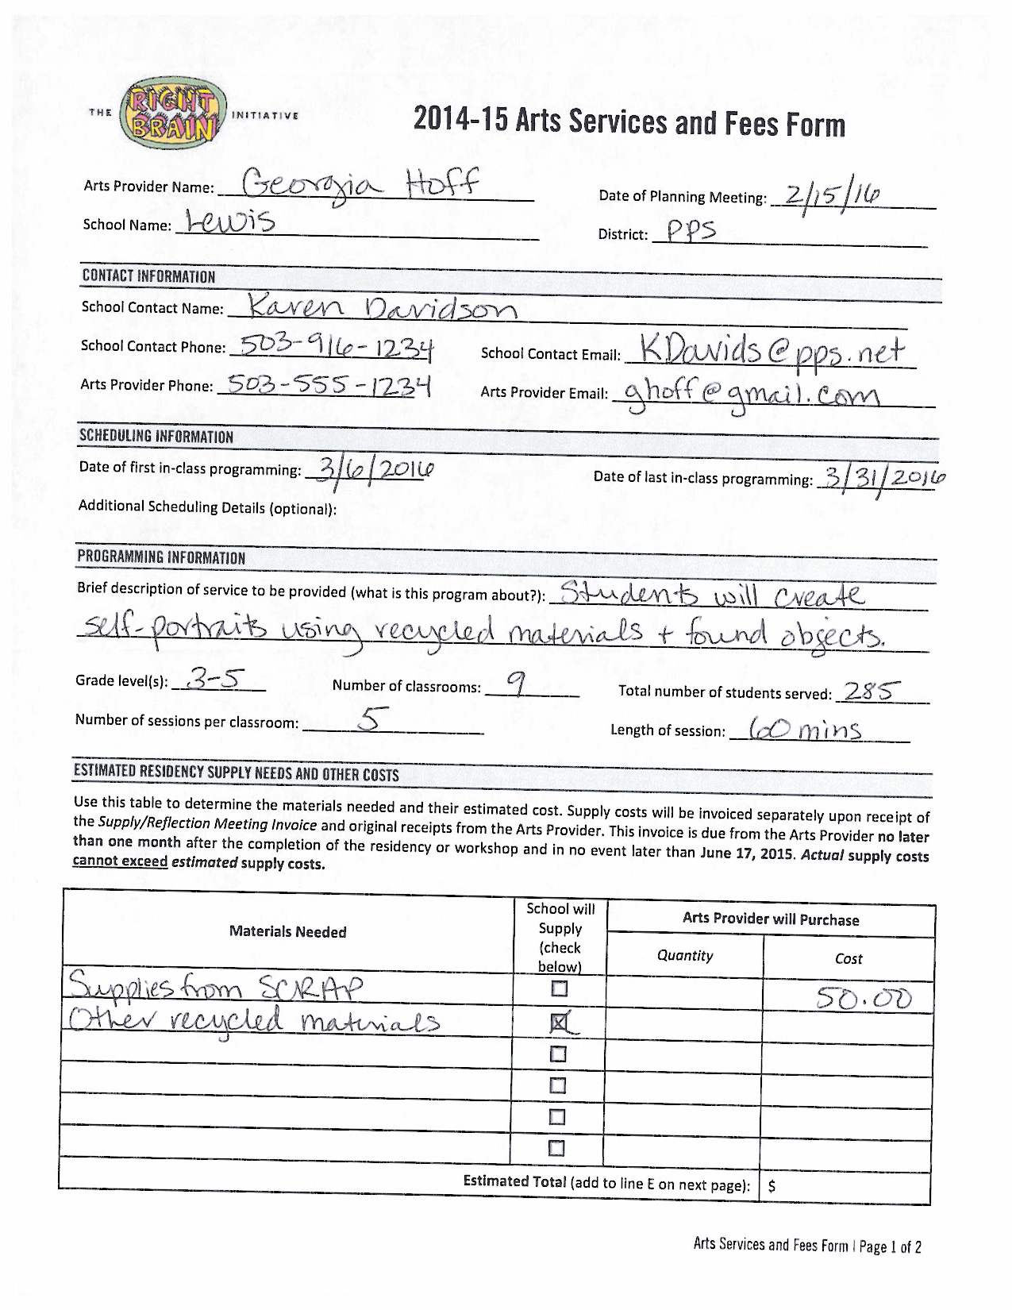
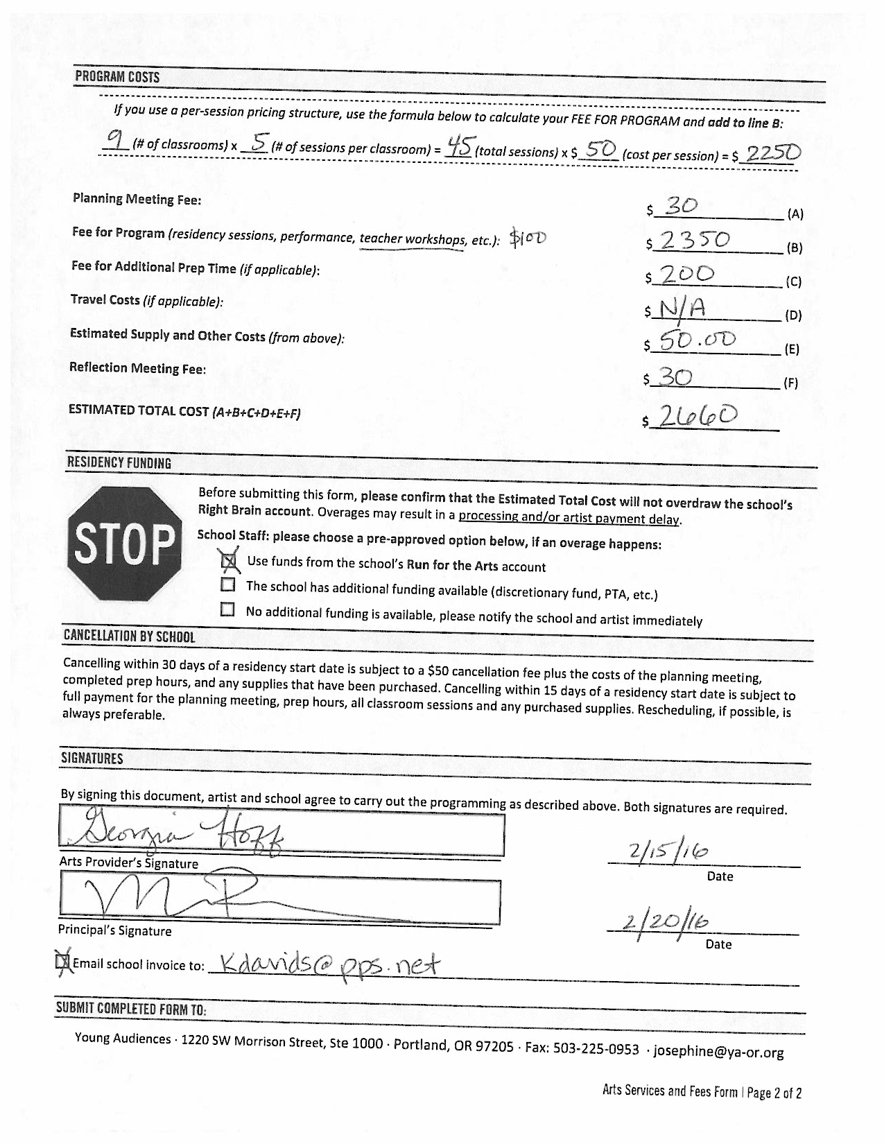

APPENDIX C: Supply/Reflection Meeting Invoice

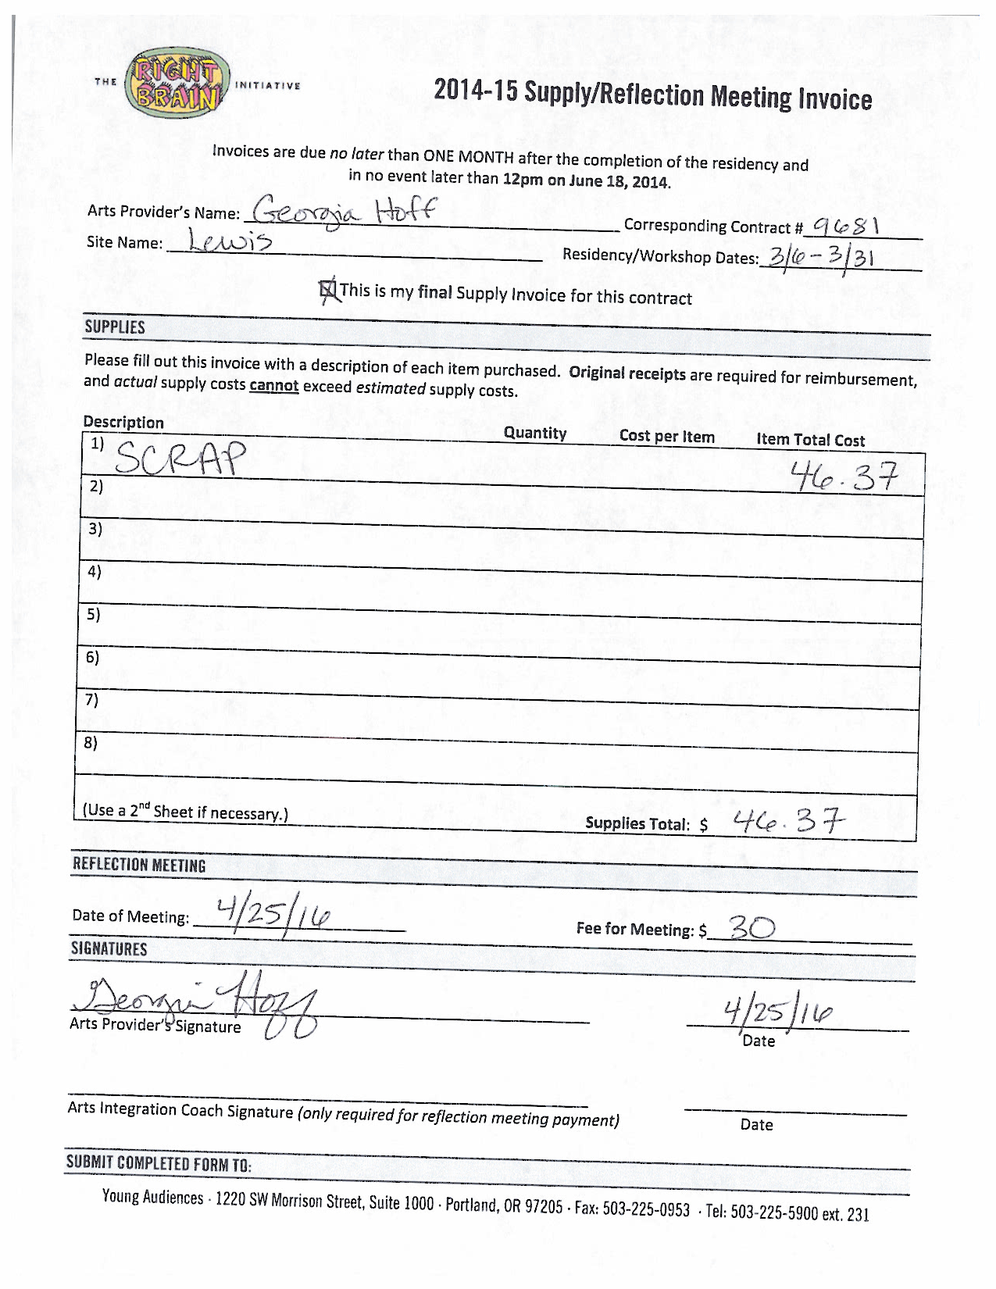
APPENDIX D: Field Trip Form

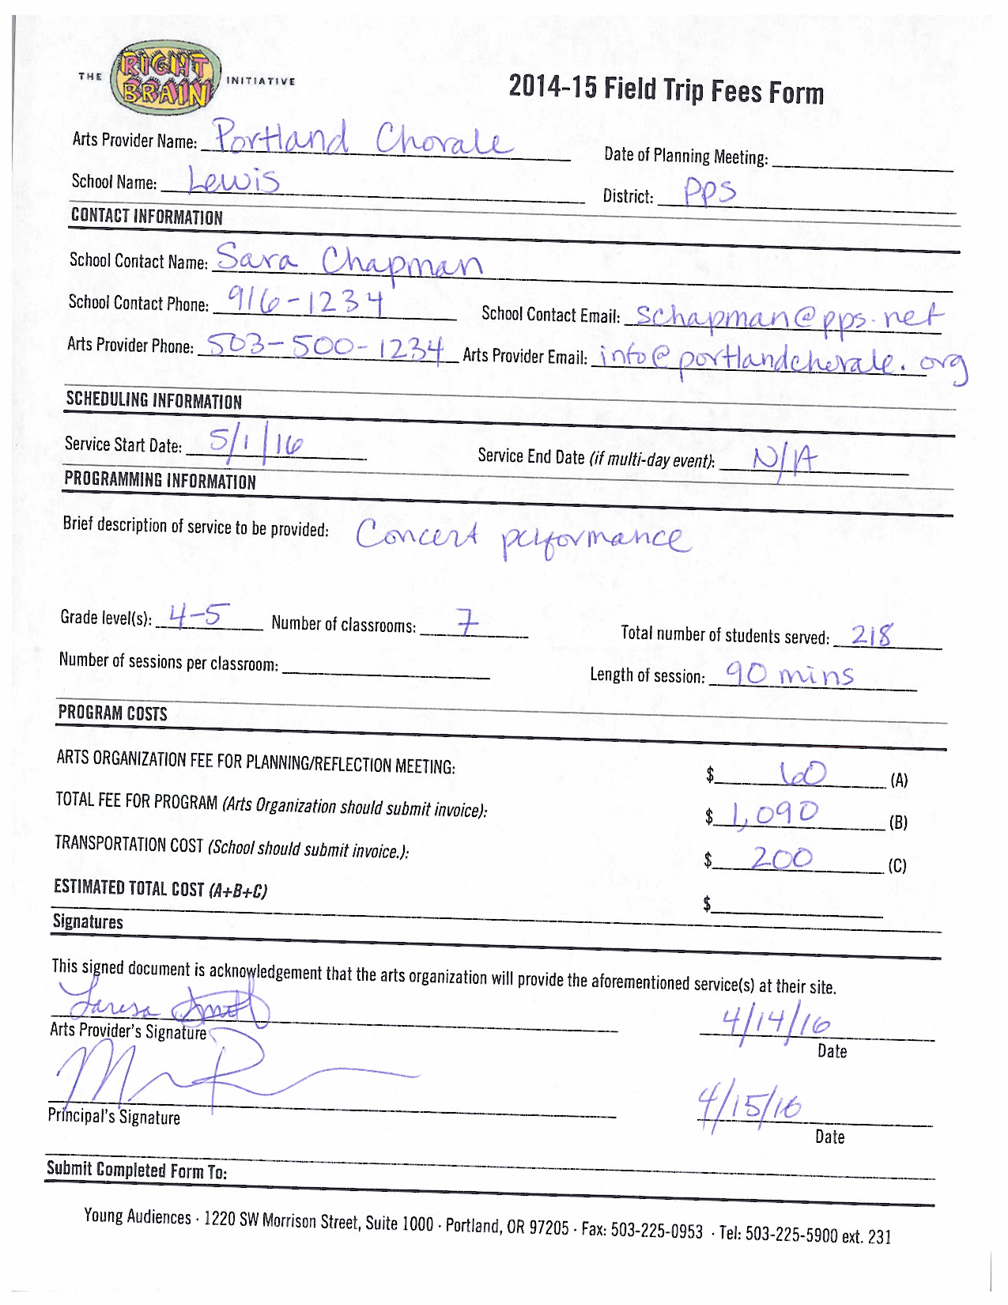
APPENDIX E: Professional Development Calendar
2015-16 Professional Development Calendar
Teachin

FALL 2015
Save the Date!
W OCT 21, 2-4p Dismantling the Ghetto of “Culturally Specific Art” Young Audiences
W NOV 18, 4-6p TBA conversation on Residency Planning Young Audiences
M DEC 14, 2-4p TBA conversation on Residency Planning Young Audiences

T | OCT 13 | 100 – Introduction to Arts Integrated Teaching and Learning | Jade/APANO Multicultural Space
TH | OCT 15
M | NOV 2
M | OCT 26 | 200 – Arts Integration: Digging Deeper | Jade/APANO Multicultural Space
TU | OCT 27
W | NOV 4 | 300 – Systems and Practices that Support School-Wide Arts  Integration | Jade/APANO Multicultural Space
TH | NOV 5

WINTER 2015

Save the Date!
W FEB 10, 2-4p TBA conversation on Reflective Practices Young Audiences

SPRING 2016

Save the Date!
TH APR 7, 2-4p TBA conversation on Shared Practices Young Audiences

TU | May 10 | Spring Reflection Colloquium | World Trade Center
W | May 11

SUMMER 2016

W | JUN 15 | Imagine This! Summer Symposium | TBD
TH | JUN 16

APPENDIX F: Right Brain Residency Plan

The Right Brain Initiative Residency Plan - Please fill in the gray areas
Follow this link to a set of instructions, prompts and a sample meeting agenda to use with this form.

School | Grade/Teacher | Artist

Essential Questions and Student Understanding
Essential Question(s):

Students will understand that:

Anchor Standards
Common Core State Standards:

National Core Art Standards:

Relevant/Anchor Texts (See Common Core Appendix B, for examples)

Right Brain Arts-Based Strategy

Quick Overview
_ sessions over _ weeks
Pre-residency-
Session 1-
Between-
Session 2-
Between-
Session 3-
Between-
Session 4-
Between-
Session 5-
Post-residency-

What students, teachers, and artists will say or do
Pre-residency
How will you build student curiosity around the residency?
Residency Day #1
Formative Assessment- What prompts and/or questions will you use to assess student understanding?

Between
How will the teacher continue the work between sessions?

Residency Day #2
Formative Assessment- What prompts and/or questions will you use to assess student understanding?

Between
How will the teacher continue the work between sessions?

Residency Day #3
Formative Assessment- What prompts and/or questions will you use to assess student understanding?

Between
How will the teacher continue the work between sessions?

Residency Day #4
Formative Assessment- What prompts and/or questions will you use to assess student understanding?

Between
How will the teacher continue the work between sessions?
Residency Day #5
Formative Assessment- What prompts and/or questions will you use to assess student understanding?

Evidence of Student Understanding
How will student understanding be demonstrated?
Extensions of Residency
How will student work be shared with the larger school community?

APPENDIX G: Teacher Feedback Form

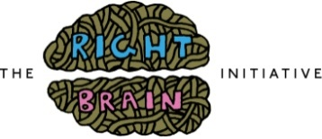 | Arts Experience  Teacher Feedback

Artist name: _______________________________Arts discipline:_____________ Dates of residency: ________
School name: ______________________________ District: _____________________Grade level: _________

Your honest feedback will be shared with the teaching artist as they reflect on their teaching practice (your name will be removed), and with Right Brain staff as part of program evaluation. Thank you!
 | Throughout | Occasionally | Seldom | Never | Anecdote to share?  (feel free to continue on the back)
Creativity
Students made their own creative choices
Reflection
Students reflected on their work and/or work of others
Student engagement
Various learning styles were accommodated and engaged
Arts integration
Students explored other curriculum area(s) in conjunction with the arts discipline

Describe an a-ha moment when you observed the objectives of this arts experience being accomplished.

What did you learn through this collaborative arts experience with a teaching artist that you’ll carry forward in your teaching, and/or that students will continue to explore in your classroom?

Please share one strong example from this arts experience that demonstrates your student’s engagement with a 21st Century Skill (critical thinking/problem solving, communication, collaboration, and creativity/innovation).

How could this arts experience have more impact in the future?

How did communication and logistics with the artist go? Please share any particularly successful strategies or areas for improvement.

Is there anything else you’d like to share? (feel free to continue on the back)

Teacher Name:_______________________________

APPENDIX H: Program Model Phases

PHASES OF IMPLEMENTATION

APPENDIX I: Residency Pathway

